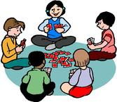
All About Me

At the moment I am really interested in… | Programmes I like to watch on TV/Favourite DVD?
My favourite toy at the moment is... | My Favourite song/nursery rhyme is...
What am I looking forward to doing at school…… | Places I like to visit……
Things I don’t like to do…… | Who lives in my house?

Name:

